Tips to Help You Use Promotional Water Bottles

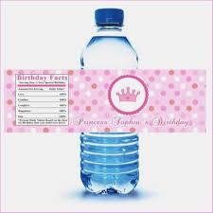

It is important to do vigorous marketing if you are launching a new product in the market or want to increase the awareness of your brand. This may result in spending a lot of money on marketing without obtaining the desired results.
The use of customized water bottles will not only increase your brand’s visibility but it is also cost-effective and a customer convenient product. If You Want To Know More About custom label water bottles, Please Check provided Link.
Brand recognition
- People like freebies a lot; therefore, you can distribute the freebies in the form of customized water bottles with your company’s logo. It will create a long-lasting impression in their mind.
- Brand recognition is another important thing to consider. By distributing custom label water bottles, you can get the needed brand recognition which will help in sustaining brand awareness.
Less expenditure
- The expenditure is quite less in comparison to other forms of advertising. It results in high quality advertisement of your brand name whenever anyone comes in contact with your customized water bottles.
- The customized water bottles can be used a number of times as they are made to be reused. This will be an added advantage to your promotion.

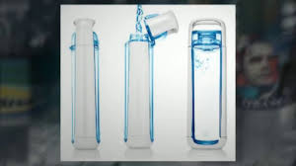

Less modification
- The customized water bottles are useful in the sense that a very little modificationis requiredto change the overall design of the product.
- These customized water bottles can be distributed in lots of different events such as product launches, conferences, etc.

